**Architectural Significant Requirements (ASRs)**

**Introduction**

We developed a set of architecturally significant requirements for the creation of the Check Inn #1 Hotel Management System in response to our client's specific needs and the changing hospitality industry landscape. These specifications resulted from an extensive process in which we carefully collaborated with our customer, a well-known Canadian hotel chain, to comprehend their objectives and difficulties.

The hospitality sector in Canada is undergoing a rapid transformation due to shifting consumer preferences and technological advancements. Travelers are expecting more and more digital hotel solutions in the present, intensely competitive climate, as our customers understand. In order to stay competitive and satisfy modern travelers, the new system streamlines operations while enhancing the customer experience. Following extensive customer feedback and market analysis, we created a thorough and functional digital platform plan that will fundamentally alter the way hotels run.

We determined the primary business drivers influencing Check Inn #1's hotel management system architectural requirements by means of comprehensive study and in-depth talks. Among these reasons were the need to promote business growth and innovation, enable integrated communications, enhance the guest experience, and streamline operations. Our architectural approach was also heavily influenced by considerations like scalability, future-proofing the system against technological advancements, and data privacy and security.

Beyond just being operationally efficient, our clients' goal also includes a dedication to sustainability, individualized care, and ongoing innovation. The formulation of architecturally significant needs that not only solve current operational issues but also provide the groundwork for long-term success and competitive differentiation is guided by this all-encompassing approach.

We examine the particular architectural specifications that resulted from these commercial goals in the ensuing sections, detailing the functionality and technical concepts that would serve as the foundation for the Check Inn #1 Hotel Management System. Our goal is to offer a strong, scalable, and future-ready solution that raises the bar for excellence in the hospitality sector by matching our architectural approach with the client's vision and strategic objectives.

**Elicitation Strategies for Architectural Requirements Gathering**

We use interviews as our elicitation method to gather architectural requirements from stakeholders. Interviewing is a method that enables direct and focused communication with stakeholders who have a vested interest in the system's architectural design and performance. The whole elicitation and designing process is continuous; hence these requirements were polished and completed after gathering feedback from stakeholders.

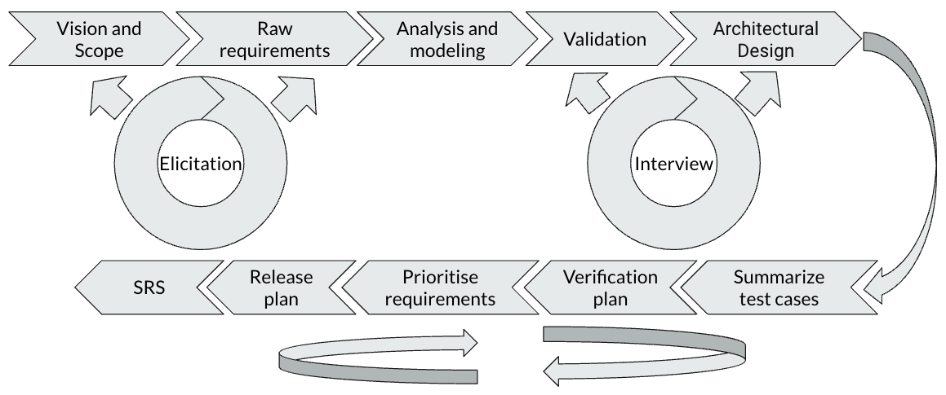

**Stakeholders Involved:**

* Architects: Provide critical insights into the system's design, ensuring scalability, reliability, and performance within the AWS ecosystem. They help define the system's architecture, considering factors like load balancing, data storage, and disaster recovery.
* Software Development Managers: Offer perspectives on integrating architectural requirements with software development processes, aligning system architecture with agile methodologies, and ensuring the system supports continuous integration and deployment.
* IT Managers: Focus on the operational and support aspects of the system architecture. Their insights ensure that the architecture aligns with IT strategy, facilitates system maintenance, and meets service-level agreements.

**Architecturally Requirements**

**1. Scalability Requirement**

* **Description:**  The system must be able to scale up and scale down to accommodate varying user loads without compromising performance or reliability. The system needs to be able to grow with the business and handle spikes in user activity during peak periods.
* **Acceptance Criteria**
  + The system should support at least a 50% increase in concurrent users and transactions compared to current load levels.
  + Scalability testing should demonstrate that the system can handle a load equivalent to 1000 concurrent users without major outage.

**2. Integration Requirement**

* **Description:** The system must integrate seamlessly with existing hotel management systems and third-party services. Ensure smooth transfer of data between services within the suite of systems.
* **Acceptance Criteria**
  + Integration testing should confirm interoperability with at least three commonly used hotel management systems and two third-party services.
  + Data migration testing should ensure that 99% of existing data is transferred to the new system accurately and without loss or corruption.
  + Application Programming Interfaces (APIs) shall be provided for integration with at least five third-party services with documented usage guidelines.

**3. Data Security and Privacy Requirement**

* **Description:** To prevent unauthorized access or disclosure of sensitive information, systems must prioritize the security and privacy of visitor data and adhere to industry standards and regulations.
* **Acceptance Criteria**
  + An industry-standard security framework that finds and fixes at least 95% of vulnerabilities should be used as the benchmark for security checks.
  + Encryption methods must be put in place to safeguard all sensitive data while it is in transit and at rest.

**4. Operational Efficiency Requirement**

* **Description:** The system must streamline hotel operations and automate routine tasks to improve efficiency, reduce errors, and free up staff time for more value-added activities.
* **Acceptance Criteria**
  + Automation tests should demonstrate at least a 50% reduction in the time spent on manual tasks such as check-in/out and housekeeping scheduling.
  + Error rates should be reduced by at least 80% compared to pre-automation levels, with no critical errors reported within the first three months of deployment.
  + Time-tracking metrics should show a decrease in average task completion time by at least 30% within the first six months of system operation.

**5. Guest Experience Enhancement Requirement**

* **Description**: The system must optimize the guest experience by providing more personalized and convenient services from booking to check-out.
* **Acceptance Criteria**
  + 70% utilization of guest-facing features (e.g., mobile check-in/check-out) within the first three months of deployment.
  + Guest satisfaction surveys should indicate an overall customer satisfaction rate of 40% within the first year of system operation.

**6. Analytics and Insights Requirement**

* **Description**: The system must provide data analytics capabilities to analyze and observe guest behaviors, preferences, and trends to better enhance the customer experience.
* **Acceptance Criteria**
  + Analytics reports should provide a more intuitive analysis of data and increase revenue by at least 15% within the first six months of system operation.
  + Personalization features should result in at least a 10% increase in upsell revenue compared to non-personalized offerings.

**7. Flexibility and Adaptability Requirement**

* **Description:** The system must be flexible and adaptable to accommodate changing business needs, market trends, and technological advancements. This ensures that the business can stay competitive and agile in a rapidly evolving industry landscape.
* **Acceptance Criteria**
  + System architecture should support the addition of new features with minimal disruption, achieving a release cycle of at least one major feature update per quarter.
  + Change management processes should result in at least 90% user satisfaction with new feature releases, as measured by post-deployment surveys.
  + User training programs should achieve a minimum 80% proficiency rate among hotel management and staff within the first month of deployment.

**8. Reliability and Performance Requirement**

* **Description:** The system must be reliable and performant, ensuring high availability, uptime, and responsiveness to meet the demands of guests and hotel operations. This ensures that the business can deliver a consistent and quality experience to guests without disruptions or delays.
* **Acceptance Criteria**
  + Performance tests should demonstrate a response time of under 500 milliseconds and a throughput of at least 100 transactions per second under peak load conditions.
  + System monitoring should achieve a minimum uptime of 99.9% over a three-month period, with no unplanned outages lasting more than 30 minutes.
  + Service level agreements (SLAs) should be met with at least 95% compliance for uptime and availability.

**9. Training and Support Requirement**

* **Description**: The system must provide comprehensive training and support to users to ensure proficiency and maximize the value of the system. This ensures that users can effectively utilize the system to its full potential and address any issues or questions that may arise.
* **Acceptance Criteria**
  + Training materials should result in a minimum 90% proficiency rate among users, as measured by post-training assessments.
  + Support channels should maintain an average response time of under one hour for user inquiries, with at least 90% of issues resolved within 24 hours.
  + User satisfaction surveys should achieve a minimum 80% satisfaction rate with training programs and support services.

**10. Compliance with Industry Standards Requirement**

* **Description:** The system must comply with industry standards and regulations to ensure legal and regulatory compliance, protect guest data, and maintain trust and reputation. This ensures that the business operates ethically and responsibly while mitigating legal and reputational risks.
* **Acceptance Criteria**
  + Compliance audits should result in a score of at least 95% compliance with relevant regulations and industry standards, with any non-compliance issues addressed within 30 days.
  + Documentation should be provided to demonstrate compliance with applicable laws and regulations, achieving a completeness score of 100% based on audit reviews.
  + Regular updates and patches should be applied within seven days of release for critical security vulnerabilities or changes in regulatory requirements.

**11. API-Based Integration Requirement**

* **Description:** The system must support API-based integration with external systems, allowing seamless communication and data exchange between the hotel management system and third-party services. This ensures flexibility, scalability, and interoperability, enabling the system to leverage the functionalities of external services and adapt to changing business needs.
* **Acceptance Criteria**
  + API documentation should be provided for all integration endpoints, including clear descriptions of functionality, input parameters, and response formats.
  + Integration tests should demonstrate successful data exchange and functionality between the hotel management system and at least five external services via APIs.
  + Response times for API calls should be monitored, with an average response time of under 200 milliseconds for 95% of requests.

**12. Microservices Architecture Requirement**

* **Description:** The system must be designed using a microservices architecture, where functionality is divided into loosely coupled, independently deployable services. This ensures modularity, scalability, and resilience, allowing the system to evolve and scale more efficiently while minimizing dependencies and reducing the impact of failures.
* **Acceptance Criteria**
  + System architecture documentation should outline the decomposition of functionality into microservices, including clear boundaries, responsibilities, and communication protocols.
  + Deployment tests should demonstrate the ability to independently deploy and scale individual microservices without affecting the overall system performance or availability.
  + Fault tolerance mechanisms, such as circuit breakers and graceful degradation, should be implemented to ensure resilience and availability in the face of service failures.

We finished designing the architecture in accordance with the aforementioned significant architectural criteria, keeping attention to the concepts of modularity, scalability, elasticity, and security.The Check Inn #1 Hotel Management System is designed with a microservices architecture, which enables the separation of functionality into independently deployable, loosely connected services. Each microservice is responsible for a specific business function, and the flexibility of development and deployment is enhanced.

In addition, the system utilizes REST API for data interaction with third-party platforms, ensuring interoperability, adaptability, and scalability. Additionally, the architectural design incorporates strong security measures, including encryption, access control and compliance with data protection regulations, to protect sensitive guest information and maintain trust.

